Basic Concepts

Core - A core is an individual processing unit within a CPU. Modern CPUs can have multiple cores, allowing them to perform multiple tasks simultaneously.
A quad-core processor has four cores, allowing it to perform four tasks simultaneously. For instance, one core could handle your web browser, another your music player, another a download manager, and another a background system update.
Program – A program is a set of instructions written in a programming language that tells the computer how to perform a specific task
Microsoft Word is a program that allows users to create and edit documents.
Process - A process is an instance of a program that is being executed. When a program runs, the operating system creates a process to manage its execution.
When we open Microsoft Word, it becomes a process in the operating system.
Thread - A thread is the smallest unit of execution within a process. A process can have multiple threads, which share the same resources but can run independently.
Program(Ms word) -> Process(Runing Ms word) ->Thread(different pages in Ms word)
A web browser like Google Chrome might use multiple threads for different tabs, with each tab running as a separate thread.
Multitasking or MultiProcessing - Multitasking allows an operating system to run multiple tasks or processes simultaneously. On single-core CPUs, this is done through time-sharing, rapidly switching between tasks. On multi-core CPUs, true parallel execution occurs, with tasks distributed across cores. The OS scheduler balances the load, ensuring efficient and responsive system performance.
Example: We are browsing the internet while listening to music and downloading a file.
Multitasking utilizes the capabilities of a CPU and its cores. When an operating system performs multitasking, it can assign different tasks to different cores. This is more efficient than assigning all tasks to a single core.
Multithreading
Multithreading refers to the ability to execute multiple threads within a single process concurrently.
A web browser can use multithreading by having separate threads for rendering the page, running JavaScript, and managing user inputs. This makes the browser more responsive and efficient.
Multithreading enhances the efficiency of multitasking by breaking down individual tasks into smaller sub-tasks or threads. These threads can be processed simultaneously, making better use of the CPU’s capabilities.
In a single-core system: Both threads and processes are managed by the OS scheduler through time slicing and context switching to create the illusion of simultaneous execution.
In a multi-core system: Both threads and processes can run in true parallel on different cores, with the OS scheduler distributing tasks across the cores to optimize performance.
Time Slicing Definition: Time slicing divides CPU time into small intervals called time slices or quanta.
- Function: The OS scheduler allocates these time slices to different processes and threads, ensuring each gets a fair share of CPU time.
- Purpose: This prevents any single process or thread from monopolizing the CPU, improving responsiveness and enabling concurrent execution.
Context Switching Definition: Context switching is the process of saving the state of a currently running process or thread and loading the state of the next one to be executed.
- Function: When a process or thread’s time slice expires, the OS scheduler performs a context switch to move the CPU’s focus to another process or thread.
- Purpose: This allows multiple processes and threads to share the CPU, giving the appearance of simultaneous execution on a single-core CPU or improving parallelism on multi-core CPUs.
Multitasking can be achieved through multithreading where each task is divided into threads that are managed concurrently.
While multitasking typically refers to the running of multiple applications, multithreading is more granular, dealing with multiple threads within the same application or process.

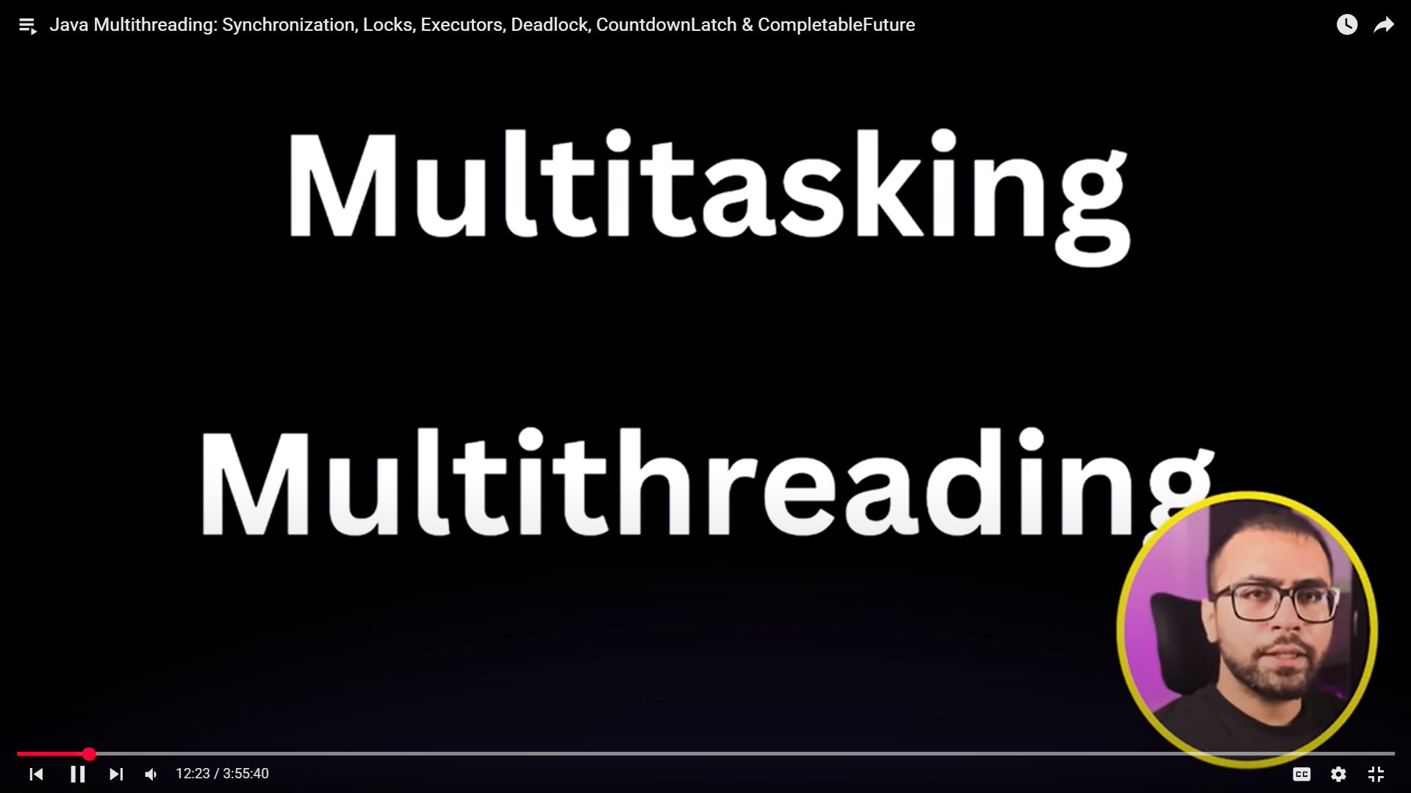

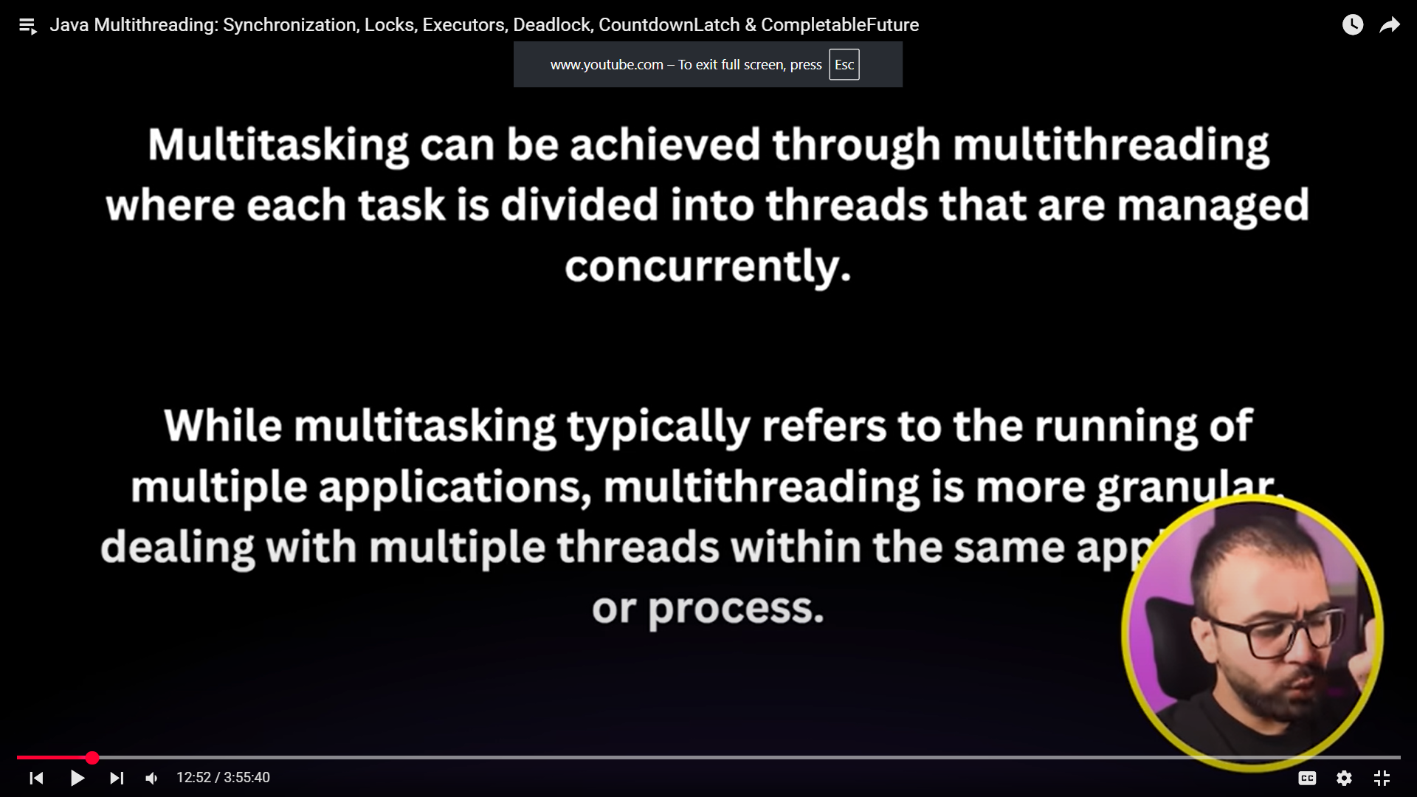

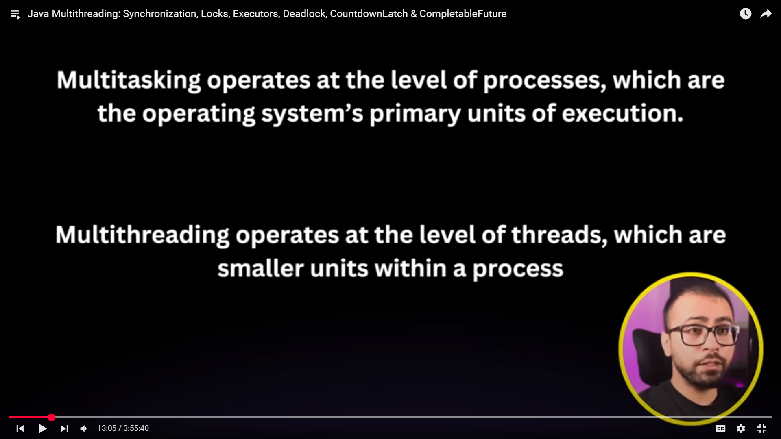

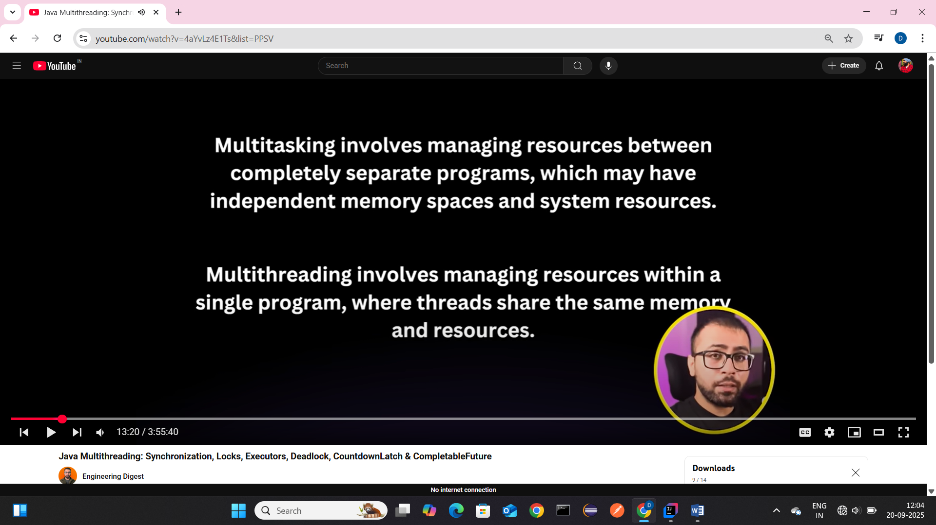

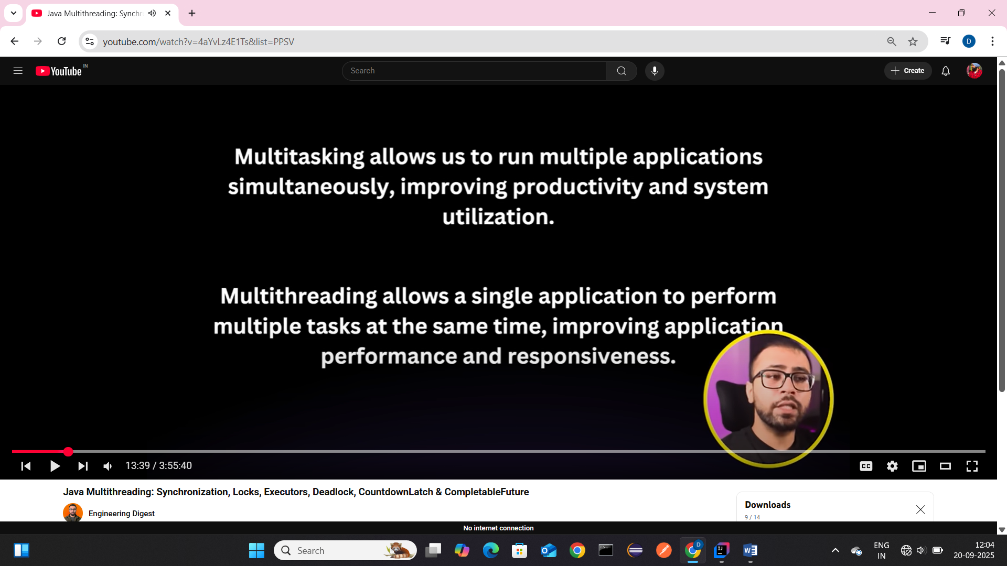

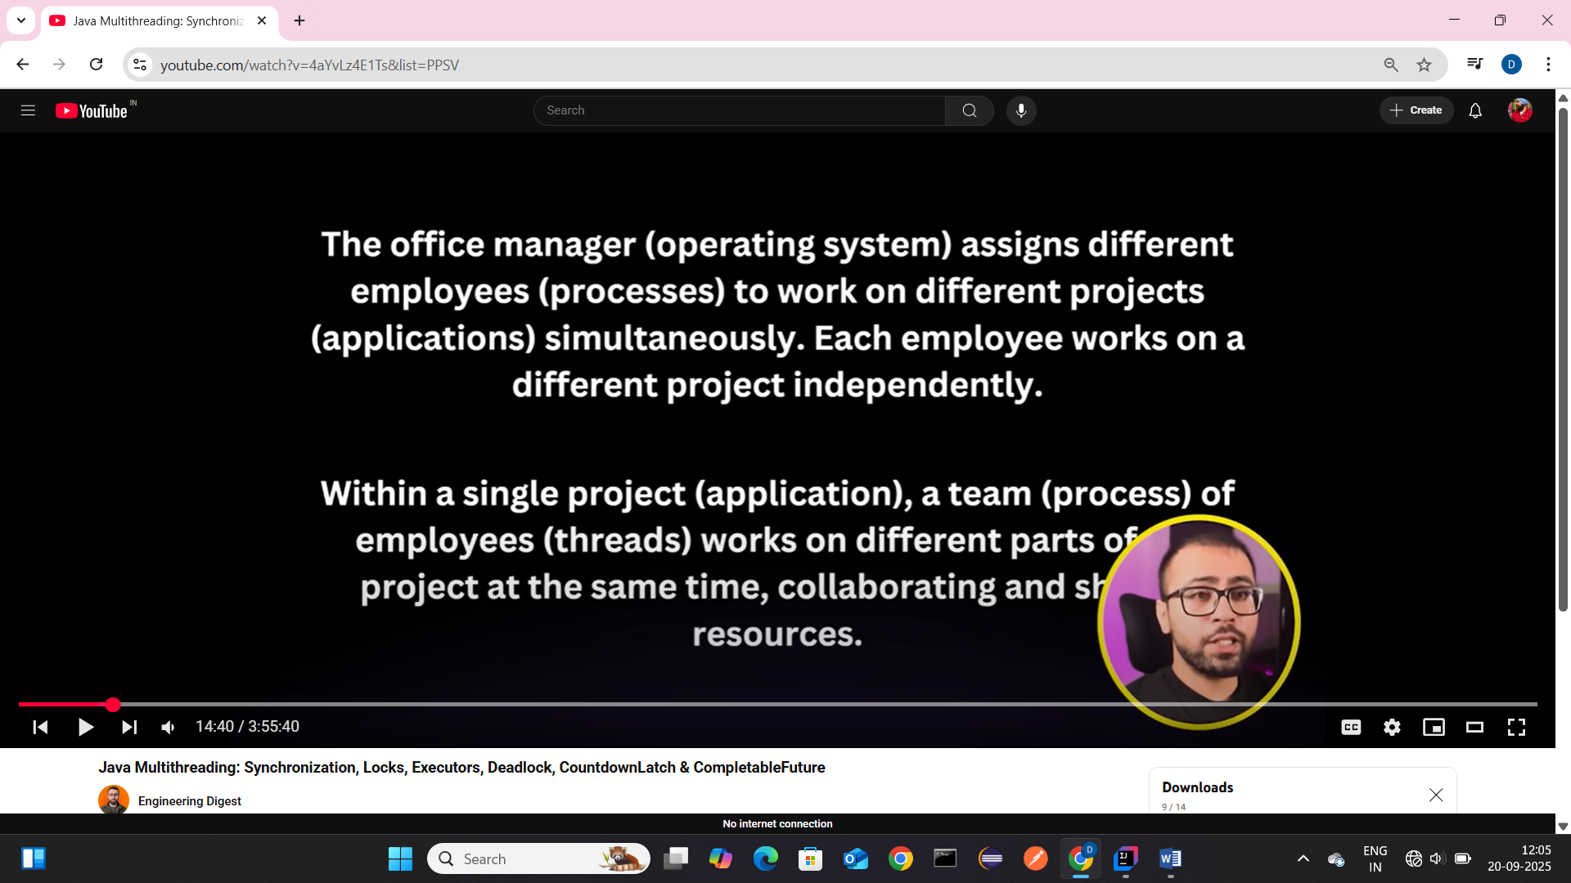

Life Cycle of Thread
During its lifetime, a thread transitions through several states, they are:
- New State
- Active State
- Waiting/Blocked State
- Timed Waiting State
- Terminated State

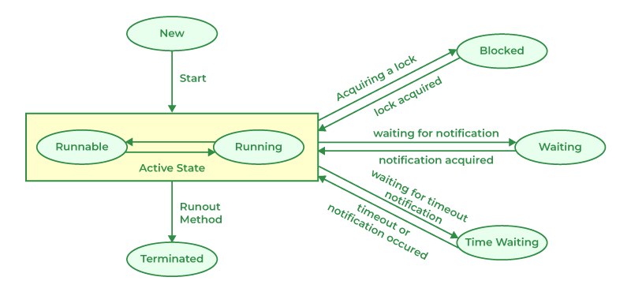

Working of Thread States
- New State: By default, a thread will be in a new state, in this state, code has not yet started execution.

2. Active State: When a thread calls the start() method, it enters the Active state, which has two sub-states:
- Runnable State: The thread is ready to run but is waiting for the Thread Scheduler to give it CPU time. Multiple runnable threads share CPU time in small slices.
- Running State: When the scheduler assigns CPU to a runnable thread, it moves to the Running state. After its time slice ends, it goes back to the Runnable state, waiting for the next chance to run.

3. Waiting/Blocked State: a thread is temporarily inactive, it may be in the Waiting or Blocked state:
- Waiting: If thread T1 needs to use a camera but thread T2 is already using it, T1 waits until T2 finishes.
- Blocked: If two threads try to use the same resource at the same time, one may be blocked until the other releases it.
When multiple threads are waiting or blocked, the Thread Scheduler decides which one gets CPU based on priority.

4. Timed Waiting State: Sometimes threads may face starvation if one thread keeps using the CPU for a long time while others keep waiting.
For example: If T1 is doing a long important task, T2 may wait indefinitely. To avoid this, Java provides the Timed Waiting state, where methods like sleep() allow a thread to pause only for a fixed time. After the time expires, the thread gets a chance to run.

5. Terminated State: A thread enters the Terminated state when its task is finished or it is explicitly stopped. In this state, the thread is dead and cannot be restarted. If you try to call start() on a terminated thread, it will throw an exception.

Multithreading in Java

Multithreading in Java is a feature that enables a program to run multiple threads simultaneously, allowing tasks to execute in parallel and utilize the CPU more efficiently. A thread is a lightweight, independent unit of execution inside a program (process).

- A process can have multiple threads.
- Each thread runs independently but shares the same memory.

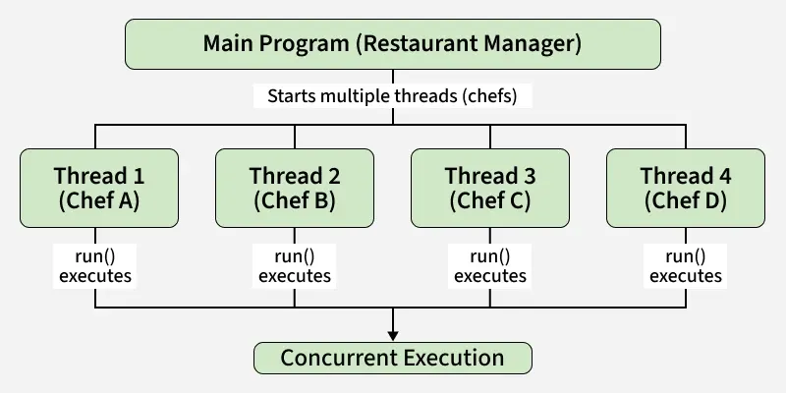
Example: Imagine a restaurant kitchen. Multiple chefs (threads) are preparing different dishes at the same time. This speeds up service and utilizes all available resources (CPU).

Multithreading Brief-
Java provides robust support for multithreading, allowing developers to create applications that can perform multiple tasks simultaneously, improving performance and responsiveness.
In Java, multithreading is the concurrent execution of two or more threads to maximize the utilization of the CPU. Java’s multithreading capabilities are part of the java.lang package, making it easy to implement concurrent execution.
In a single-core environment, Java’s multithreading is managed by the JVM and the OS, which switch between threads to give the illusion of concurrency.
The threads share the single core, and time-slicing is used to manage thread execution.
In a multi-core environment, Java’s multithreading can take full advantage of the available cores.
The JVM can distribute threads across multiple cores, allowing true parallel execution of threads.
A thread is a lightweight process, the smallest unit of processing. Java supports multithreading through its java.lang.Thread class and the java.lang.Runnable interface.
When a Java program starts, one thread begins running immediately, which is called the main thread. This thread is responsible for executing the main method of a program.
public class Test {
public static void main(String[] args) {
System.out.println("Hello world !");
}
}
To create a new thread in Java, you can either extend the Thread class or implement the Runnable interface.

Method 1: extend the Thread class
- A new class World is created that extends Thread.
- The run method is overridden to define the code that constitutes the new thread.
- start method is called to initiate the new thread.
public class Test {
public static void main(String[] args) {
World world = new World();
world.start();
for (; ; ) {
System.out.println("Hello");
}
}
}
public class World extends Thread {
@Override
public void run() {
for (; ; ) {
System.out.println("World");
}
}
}

Method 2: Implement Runnable interface
- A new class World is created that implements Runnable.
- The run method is overridden to define the code that constitutes the new thread.
- A Thread object is created by passing an instance of World.
- start method is called on the Thread object to initiate the new thread.
public class Test {
public static void main(String[] args) {
World world = new World();
Thread thread = new Thread(world);
thread.start();
for (; ; ) {
System.out.println("Hello");
}
}
}
public class World implements Runnable {
@Override
public void run() {
for (; ; ) {
System.out.println("World");
}
}
}

Thread Lifecycle
The lifecycle of a thread in Java consists of several states, which a thread can move through during its execution.
- New: A thread is in this state when it is created but not yet started.
- Runnable: After the start method is called, the thread becomes runnable. It’s ready to run and is waiting for CPU time.
- Running: The thread is in this state when it is executing.
- Blocked/Waiting: A thread is in this state when it is waiting for a resource or for another thread to perform an action.
- Terminated: A thread is in this state when it has finished executing.
public class MyThread extends Thread{
@Override
public void run() {
System.out.println("RUNNING"); // RUNNING
try {
Thread.sleep(2000);
} catch (InterruptedException e) {
System.out.println(e);
}
}
public static void main(String[] args) throws InterruptedException {
MyThread t1 = new MyThread();
System.out.println(t1.getState()); // NEW
t1.start();
System.out.println(t1.getState()); // RUNNABLE
Thread.sleep(100);
System.out.println(t1.getState()); // TIMED_WAITING
t1.join();
System.out.println(t1.getState()); // TERMINATED
}
}

Runnable vs Thread
- Use Runnable when you want to separate the task from the thread, allowing the class to extend another class if needed. Extend Thread if you need to override Thread methods or if the task inherently requires direct control over the thread itself, though this limits inheritance.
If you mean a typical process/lifecycle API, the reason is that start and run usually represent different responsibilities:
  - start() initializes the component and begins its lifecycle, often asynchronously.
  - run() performs the actual work, commonly as a blocking operation or the main execution loop.
  - Calling run() directly can bypass initialization that start() is responsible for—configuration, thread/event-loop setup, state transitions, resource allocation, etc.
For example:
start()
├─ initialize()
├─ create resources/thread
└─ run()
So run() isn't necessarily an alternative to start(); it may be an internal execution step that assumes the object has already been started.
If you're referring to a specific framework/API where you're wondering why you can't invoke run() directly instead of start(), tell me which one (e.g. Java Thread, Python, an agent framework), and I can explain the exact reason.

You said:
runnable vs thread

ChatGPT said:
If you're asking about Java's Runnable vs Thread, the key distinction is:
  - Runnable = the work to be done
  - Thread = the thing that executes that work concurrently

Example
Runnable task = () -> {
System.out.println("Doing work");
};

Thread thread = new Thread(task);
thread.start();
Here:
Runnable → defines WHAT to execute
Thread → defines WHERE/HOW it executes

Why run() vs start() matters
This is the important part:
thread.run();
does not create a new thread. It simply calls run() like a normal method:
main thread
|
└── run()
└── task executes here
Whereas:
thread.start();
asks the JVM to create/start a separate thread, which eventually invokes run():
main thread new thread
| |
| start() ------------> |
|
└── run()
└── task
So you generally use:
thread.start(); // concurrent execution
not:
thread.run(); // just a normal method call

Why have Runnable at all?
Because Java separates the task from the thread.
You can write:
class MyTask implements Runnable {
public void run() {
// work
}
}
and then choose how to execute it:
new Thread(new MyTask()).start();
Or, more commonly, give it to an executor:
ExecutorService executor = Executors.newFixedThreadPool(4);

executor.submit(new MyTask());
This is one reason Runnable is generally preferred over extending Thread: your class represents the work, while the executor/thread manages how that work gets executed.
The mental model to remember is:
Runnable.run() is the job. Thread.start() starts a worker that performs the jo

Thread methods
- start( ): Begins the execution of the thread. The Java Virtual Machine (JVM) calls the run() method of the thread.
- run( ): The entry point for the thread. When the thread is started, the run() method is invoked. If the thread was created using a class that implements Runnable, the run() method will execute the run() method of that Runnable object.
- sleep(long millis): Causes the currently executing thread to sleep (temporarily cease execution) for the specified number of milliseconds.
- join( ): Waits for this thread to die. When one thread calls the join() method of another thread, it pauses the execution of the current thread until the thread being joined has completed its execution.
- setPriority(int newPriority): Changes the priority of the thread. The priority is a value between Thread.MIN_PRIORITY (1) and Thread.MAX_PRIORITY (10).
public class MyThread extends Thread {
public MyThread(String name) {
super(name);
}
@Override
public void run() {
System.out.println("Thread is Running...");
for (int i = 1; i <= 5; i++) {
for (int j = 0; j < 5; j++) {
System.out.println(Thread.currentThread().getName() + " - Priority: " + Thread.currentThread().getPriority() + " - count: " + i);
try {
Thread.sleep(1000);
} catch (InterruptedException e) {
e.printStackTrace();
}
}
}
}
public static void main(String[] args) throws InterruptedException {
MyThread l = new MyThread("Low Priority Thread");
MyThread m = new MyThread("Medium Priority Thread");
MyThread n = new MyThread("High Priority Thread");
l.setPriority(Thread.MIN_PRIORITY);
m.setPriority(Thread.NORM_PRIORITY);
n.setPriority(Thread.MAX_PRIORITY);
l.start();
m.start();
n.start();
}
}
Not useless — but limited. The important distinction is:
Priority is useful when you care about relative CPU preference, but you don't care about exact execution order.
Think of it as "importance", not "turn order."

A practical example
Imagine a server has three kinds of work:
HIGH → process payment
NORMAL → generate report
LOW → cleanup temporary files
You could have:
paymentThread.setPriority(Thread.MAX_PRIORITY);
reportThread.setPriority(Thread.NORM_PRIORITY);
cleanupThread.setPriority(Thread.MIN_PRIORITY);
The intention is:
Payment processing
↑
important
|
Report generation
|
Cleanup
↓
less important
If the CPU is under heavy contention, the scheduler can favor the payment-processing thread.
But you're not saying:
1. Payment MUST execute
2. Then report MUST execute
3. Then cleanup MUST execute
You're saying:
"If these threads are competing for CPU, I'd prefer the payment work to receive more scheduling attention."

But here's the catch
For modern Java applications, you generally should not use thread priority as your main mechanism for controlling application behavior.
For example, don't do this:
t1.setPriority(1);
t2.setPriority(10);
and expect:
t2 → gets 80% CPU
t1 → gets 20% CPU
There is no such guarantee.
The exact effect depends on the JVM, operating system, scheduler, CPU, and workload.
So your feeling of:
"Then what's the point?"
is actually a good question.

The answer is: priority is a hint for scheduling, not a synchronization mechanism.

Think about 3 different requirements
This makes it much clearer.

Requirement 1: "This work is more important"
Priority may be appropriate:
highPriorityThread.setPriority(Thread.MAX_PRIORITY);
lowPriorityThread.setPriority(Thread.MIN_PRIORITY);
You're expressing:
High-priority work should generally receive preference.

Requirement 2: "A must execute before B"
Priority is NOT appropriate.
You need ordering:
a.start();
a.join();

b.start();
Now you have:
A finishes
↓
B starts
That's a guarantee.

Requirement 3: "B can only run after A signals it"
Priority is again not appropriate.
You'd use something like:
CountDownLatch
Semaphore
Lock
wait/notify
Condition
depending on the situation.

Here's the easiest way to remember it
Imagine a hospital.
There are three patients:
Patient A → emergency
Patient B → normal
Patient C → minor
Priority means:
A should generally receive attention before C.
But it doesn't mean:
Doctor MUST finish A
↓
then MUST finish B
↓
then MUST finish C
Maybe A needs to wait for an X-ray.
While A is waiting:
A → waiting for X-ray
B → doctor can work on B
C → maybe gets some attention
That's similar to thread scheduling.

One more important thing: Thread priority isn't usually how you'd design a modern Java server
Suppose you're building an e-commerce application.
You might have:
Order processing
Email sending
Image resizing
Log cleanup
Rather than relying on:
orderThread.setPriority(10);
emailThread.setPriority(5);
cleanupThread.setPriority(1);
you'd generally design separate executors/thread pools or queues.
Conceptually:
HIGH PRIORITY QUEUE
↓
Order processing workers

NORMAL QUEUE
↓
Email workers

LOW PRIORITY QUEUE
↓
Cleanup workers
Now you control the architecture, instead of hoping the OS scheduler gives you the behavior you want.

So is Java priority "useless"?
I'd phrase it this way:
No, but it is not a tool for deterministic thread control.
Its usefulness is:
Thread Priority
|
scheduling preference
|
+-----------+-----------+
| |
Higher priority Lower priority
| |
may get preference may get less preference
It is not:
priority 10 → run first ❌
priority 10 → finish first ❌
priority 10 → get exactly 2x CPU ❌
priority 10 → interrupt p1 ❌
The strongest mental model is:
Priority tells the scheduler "how important this thread is relative to other runnable threads." It does not tell the scheduler "run this thread now."
And that's why your experiment with t1, t2, and t3 is actually useful: run it 10–20 times and observe that the output order changes. That demonstrates exactly why priority ≠ ordering.
6. interrupt(): Interrupts the thread. If the thread is blocked in a call to wait(), sleep(), or join(), it will throw an InterruptedException.

interrupt() — cooperative cancellation ✅
Instead:
t1.interrupt();
you are saying:
"Hey t1, please stop when you get a chance."
The thread can then decide how to safely stop.
Example:
Thread t1 = new Thread(() -> {

while (!Thread.currentThread().isInterrupted()) {

doWork();
}

cleanup();
});
Now:
t1.interrupt();
causes:
interrupt request
↓
worker notices it
↓
finish/cleanup
↓
exit normally

7. yield(): Thread.yield() is a static method that suggests the current thread temporarily pause its execution to allow other threads of the same or higher priority to execute. It’s important to note that yield() is just a hint to the thread scheduler, and the actual behavior may vary depending on the JVM and OS.
public class MyThread extends Thread {
@Override
public void run() {
for (int i = 0; i < 5; i++) {
System.out.println(Thread.currentThread().getName() + " is running...");
Thread.yield();
}
}
public static void main(String[] args) {
MyThread t1 = new MyThread();
MyThread t2 = new MyThread();
t1.start();
t2.start();
}
}
8. Thread.setDaemon(boolean): Marks the thread as either a daemon thread or a user thread. When the JVM exits, all daemon threads are terminated.
public class MyThread extends Thread {
@Override
public void run() {
while (true) {
System.out.println("Hello world! ");
}
}
public static void main(String[] args) {
MyThread myThread = new MyThread();
myThread.setDaemon(true); // myThread is daemon thread ( like Garbage collector ) now
MyThread t1 = new MyThread();
t1.start(); // t1 is user thread
myThread.start();
System.out.println("Main Done");
}
}

Synchronisation
Let’s see an example where two threads are incrementing same couter.
class Counter {
private int count = 0; // shared resource
public void increment() {
count++;
}
public int getCount() {
return count;
}
}
public class MyThread extends Thread {
private Counter counter;
public MyThread(Counter counter) {
this.counter = counter;
}
@Override
public void run() {
for (int i = 0; i < 1000; i++) {
counter.increment();
}
}
public static void main(String[] args) {
Counter counter = new Counter();
MyThread t1 = new MyThread(counter);
MyThread t2 = new MyThread(counter);
t1.start();
t2.start();
try {
t1.join();
t2.join();
}catch (Exception e){
}
System.out.println(counter.getCount()); // Expected: 2000, Actual will be random <= 2000
}
}
The output of the code is not 2000 because the increment method in the Counter class is not synchronized. This results in a race condition when both threads try to increment the count variable concurrently.
Without synchronization, one thread might read the value of count before the other thread has finished writing its incremented value. This can lead to both threads reading the same value, incrementing it, and writing it back, effectively losing one of the increments.
We can fix this by using synchronized keyword
class Counter {
private int count = 0; // shared resource
public synchronized void increment() {
count++;
}
public int getCount() {
return count;
}
}
By synchronizing the increment method, you ensure that only one thread can execute this method at a time, which prevents the race condition. With this change, the output will consistently be 2000.

Locks
The synchronized keyword in Java provides basic thread-safety but has limitations: it locks the entire method or block, leading to potential performance issues. It lacks a try-lock mechanism, causing threads to block indefinitely, increasing the risk of deadlocks. Additionally, synchronized doesn't support multiple condition variables, offering only a single monitor per object with basic wait/notify mechanisms. In contrast, explicit locks (Lock interface) offer finer-grained control, try-lock capabilities to avoid blocking, and more sophisticated thread coordination through multiple condition variables, making them more flexible and powerful for complex concurrency scenarios.

Intrinsic Locks (also called monitor locks)
- What?
Every Java object has an implicit, built-in lock associated with it, called an intrinsic lock or monitor.
- How is it used?
The synchronized keyword leverages these intrinsic locks to provide mutual exclusion.
- Example:
- public synchronized void doSomething() {
- // Only one thread can execute this method on the same object at a time
}
• Behavior:
- When a thread enters a synchronized block or method, it acquires the intrinsic lock of the specified object.
- Other threads trying to enter a synchronized block on the same object must wait.
- The lock is released automatically when the thread exits the synchronized block/method.
• Advantages:
- Easy to use.
- No explicit lock management needed.
• Limitations:
- No ability to try lock without blocking (tryLock).
- No support for timed waits or interruptible lock acquisition.
- Coarse-grained control.

Explicit Locks (from java.util.concurrent.locks package)
- What?
Explicit locks are lock objects, such as ReentrantLock, that you create and manage yourself.
- How is it used?
- import java.util.concurrent.locks.Lock;
- import java.util.concurrent.locks.ReentrantLock;

- public class Counter {
- private final Lock lock = new ReentrantLock();
- private int count = 0;

- public void increment() {
- lock.lock(); // acquire the lock
- try {
- count++;
- } finally {
- lock.unlock(); // make sure to unlock
- }
- }
- }
- Features:
  - Can attempt to acquire the lock without blocking (tryLock()).
  - Can acquire the lock with a timeout (tryLock(long time, TimeUnit unit)).
  - Supports interruptible lock acquisition (lockInterruptibly()).
  - Can have multiple condition variables (newCondition()), enabling advanced thread signaling.
- Advantages:
  - More flexible and powerful than intrinsic locks.
  - Better suited for complex synchronization scenarios.
- Disadvantages:
  - More verbose.
  - Requires explicit lock release, so you must be careful to avoid deadlocks or forgetting to unlock.

Feature | Intrinsic Lock (synchronized) | Explicit Lock (ReentrantLock)
Lock object per instance | Implicit (per object) | Explicit (you create the Lock)
Syntax | synchronized keyword | lock.lock() / lock.unlock()
Try lock with timeout | No | Yes (tryLock(timeout))
Interruptible lock | No | Yes (lockInterruptibly())
Multiple conditions | No | Yes (newCondition())
Automatic unlock | Yes (on exit of synchronized) | No (manual unlock needed)
Use case | Simple mutual exclusion | Complex synchronization scenarios

Example for explicit locks to be used:-

import java.util.concurrent.TimeUnit;
import java.util.concurrent.locks.Lock;
import java.util.concurrent.locks.ReentrantLock;
public class BankAccount {
private int balance = 100;
private final Lock lock = new ReentrantLock();
public void withdraw(int amount) {
System.out.println(Thread.currentThread().getName() + " attempting to withdraw " + amount);
try {
if (lock.tryLock(1000, TimeUnit.MILLISECONDS)) {
if (balance >= amount) {
try {
System.out.println(Thread.currentThread().getName() + " proceeding with withdrawal");
Thread.sleep(3000); // Simulate time taken to process the withdrawal
balance -= amount;
System.out.println(Thread.currentThread().getName() + " completed withdrawal. Remaining balance: " + balance);
} catch (Exception e) {
Thread.currentThread().interrupt();
} finally {
lock.unlock();
}
} else {
System.out.println(Thread.currentThread().getName() + " insufficient balance");
}
} else {
System.out.println(Thread.currentThread().getName() + " could not acquire the lock, will try later");
}
} catch (Exception e) {
Thread.currentThread().interrupt();
}
}
}
public class Main {
public static void main(String[] args) {
BankAccount sbi = new BankAccount();
Runnable task = new Runnable() {
@Override
public void run() {
sbi.withdraw(50);
}
};
Thread t1 = new Thread(task, "Thread 1");
Thread t2 = new Thread(task, "Thread 2");
t1.start();
t2.start();
}
}

Reentrant Lock
A Reentrant Lock in Java is a type of lock that allows a thread to acquire the same lock multiple times without causing a deadlock. If a thread already holds the lock, it can re-enter the lock without being blocked. This is useful when a thread needs to repeatedly enter synchronized blocks or methods within the same execution flow. The ReentrantLock class from the java.util.concurrent.locks package provides this functionality, offering more flexibility than the synchronized keyword, including try-locking, timed locking, and multiple condition variables for advanced thread coordination.

public class ReentrantExample {
private final Lock lock = new ReentrantLock();
public void outerMethod() {
lock.lock();
try {
System.out.println("Outer method");
innerMethod();
} finally {
lock.unlock();
}
}
public void innerMethod() {
lock.lock();
try {
System.out.println("Inner method");
} finally {
lock.unlock();
}
}
public static void main(String[] args) {
ReentrantExample example = new ReentrantExample();
example.outerMethod();
}
}
A reentrant lock is a lock that allows the same thread to acquire the lock multiple times without getting stuck.
Think of it like a room with a key:
- A thread enters the room and locks the door.
- While inside, it calls another function that also wants to enter the same room.
- Because it is the same thread, a reentrant lock says: "You're already inside—come on in."
- The thread can lock it again.
- But it must unlock the same number of times before the door is actually unlocked.

Example
Thread A:
lock()

function1():
lock() ← allowed because Thread A already owns it
unlock()

unlock()
With a normal non-reentrant lock, the second lock() could cause Thread A to wait for itself forever:
Thread A gets lock
↓
Thread A calls another function
↓
That function tries to get the same lock
↓
Thread A waits...
↓
But only Thread A can release the lock
↓
💥 Deadlock
With a reentrant lock:
Thread A gets lock → lock count = 1
Thread A gets it again → lock count = 2
Thread A releases → lock count = 1
Thread A releases → lock count = 0
↓
unlocked

The key idea
Reentrant = "I already own this lock, so I can acquire it again."
It's particularly useful when a synchronized/locked function calls another synchronized/locked function that uses the same lock.
For example, in Java, ReentrantLock is specifically designed for this behavior.

Methods of ReentrantLock
lock()
- Acquires the lock, blocking the current thread until the lock is available. It would block the thread until the lock becomes available, potentially leading to situations where a thread waits indefinitely.
- If the lock is already held by another thread, the current thread will wait until it can acquire the lock.
tryLock()
- Tries to acquire the lock without waiting. Returns true if the lock was acquired, false otherwise.
- This is non-blocking, meaning the thread will not wait if the lock is not available.
tryLock(long timeout, TimeUnit unit)
- Attempts to acquire the lock, but with a timeout. If the lock is not available, the thread waits for the specified time before giving up. It is used when you want to attempt to acquire the lock without waiting indefinitely. It allows the thread to proceed with other work if the lock isn't available within the specified time. This approach is useful to avoid deadlock scenarios and when you don't want a thread to block forever waiting for a lock.
- Returns true if the lock was acquired within the timeout, false otherwise.
unlock()
- Releases the lock held by the current thread.
- Must be called in a finally block to ensure that the lock is always released even if an exception occurs.
lockInterruptibly()
- Acquires the lock unless the current thread is interrupted. This is useful when you want to handle interruptions while acquiring a lock.

Read Write Lock
A Read-Write Lock is a concurrency control mechanism that allows multiple threads to read shared data simultaneously while restricting write access to a single thread at a time. This lock type, provided by the ReentrantReadWriteLock class in Java, optimizes performance in scenarios with frequent read operations and infrequent writes. Multiple readers can acquire the read lock without blocking each other, but when a thread needs to write, it must acquire the write lock, ensuring exclusive access. This prevents data inconsistency while improving read efficiency compared to traditional locks, which block all access during write operations.
import java.util.concurrent.locks.Lock;
import java.util.concurrent.locks.ReadWriteLock;
import java.util.concurrent.locks.ReentrantReadWriteLock;
public class ReadWriteCounter {
private int count = 0;
private final ReadWriteLock lock = new ReentrantReadWriteLock();
private final Lock readLock = lock.readLock();
private final Lock writeLock = lock.writeLock();
public void increment() {
writeLock.lock();
try {
count++;
Thread.sleep(50);
} catch (InterruptedException e) {
throw new RuntimeException(e);
} finally {
writeLock.unlock();
}
}
public int getCount() {
readLock.lock();
try {
return count;
} finally {
readLock.unlock();
}
}
public static void main(String[] args) throws InterruptedException {
ReadWriteCounter counter = new ReadWriteCounter();
Runnable readTask = new Runnable() {
@Override
public void run() {
for (int i = 0; i < 10; i++) {
System.out.println(Thread.currentThread().getName() + " read: " + counter.getCount());
}
}
};
Runnable writeTask = new Runnable() {
@Override
public void run() {
for (int i = 0; i < 10; i++) {
counter.increment();
System.out.println(Thread.currentThread().getName() + " incremented");
}
}
};
Thread writerThread = new Thread(writeTask);
Thread readerThread1 = new Thread(readTask);
Thread readerThread2 = new Thread(readTask);
writerThread.start();
readerThread1.start();
readerThread2.start();
writerThread.join();
readerThread1.join();
readerThread2.join();
System.out.println("Final count: " + counter.getCount());
}
}

Fairness of Locks
Fairness in the context of locks refers to the order in which threads acquire a lock. A fair lock ensures that threads acquire the lock in the order they requested it, preventing thread starvation. With a fair lock, if multiple threads are waiting, the longest-waiting thread is granted the lock next. However, fairness can lead to lower throughput due to the overhead of maintaining the order. Non-fair locks, in contrast, allow threads to “cut in line,” potentially offering better performance but at the risk of some threads waiting indefinitely if others frequently acquire the lock.
import java.util.concurrent.locks.Lock;
import java.util.concurrent.locks.ReadWriteLock;
import java.util.concurrent.locks.ReentrantReadWriteLock;
public class FairnessLockExample {
private final Lock lock = new ReentrantLock(true);
public void accessResource() {
lock.lock();
try {
System.out.println(Thread.currentThread().getName() + " acquired the lock.");
Thread.sleep(1000);
} catch (InterruptedException e) {
Thread.currentThread().interrupt();
} finally {
System.out.println(Thread.currentThread().getName() + " released the lock.");
lock.unlock();
}
}
public static void main(String[] args) {
FairnessLockExample example = new FairnessLockExample();
Runnable task = new Runnable() {
@Override
public void run() {
example.accessResource();
}
};
Thread thread1 = new Thread(task, "Thread 1");
Thread thread2 = new Thread(task, "Thread 2");
Thread thread3 = new Thread(task, "Thread 3");
thread1.start();
thread2.start();
thread3.start();
}
}

Side-by-Side Comparison
Standard Lock:
[Reader 1] ---> ENTERS (Locks everyone else out)
[Reader 2] ---> WAITS...

Read/Write Lock:
[Reader 1] ---> ENTERS
[Reader 2] ---> ENTERS TOGETHER WITH READER 1 (Fast!)
When a Writer arrives in Read/Write Lock:
[Writer] ---> WAITS for readers to finish
[Reader 1] ---> Finishes & leaves
[Writer] ---> ENTERS ALONE (Locks out readers and other writers)

Deadlock
A deadlock occurs in concurrent programming when two or more threads are blocked forever, each waiting for the other to release a resource. This typically happens when threads hold locks on resources and request additional locks held by other threads. For example, Thread A holds Lock 1 and waits for Lock 2, while Thread B holds Lock 2 and waits for Lock 1. Since neither thread can proceed, they remain stuck in a deadlock state. Deadlocks can severely impact system performance and are challenging to debug and resolve in multi-threaded applications.

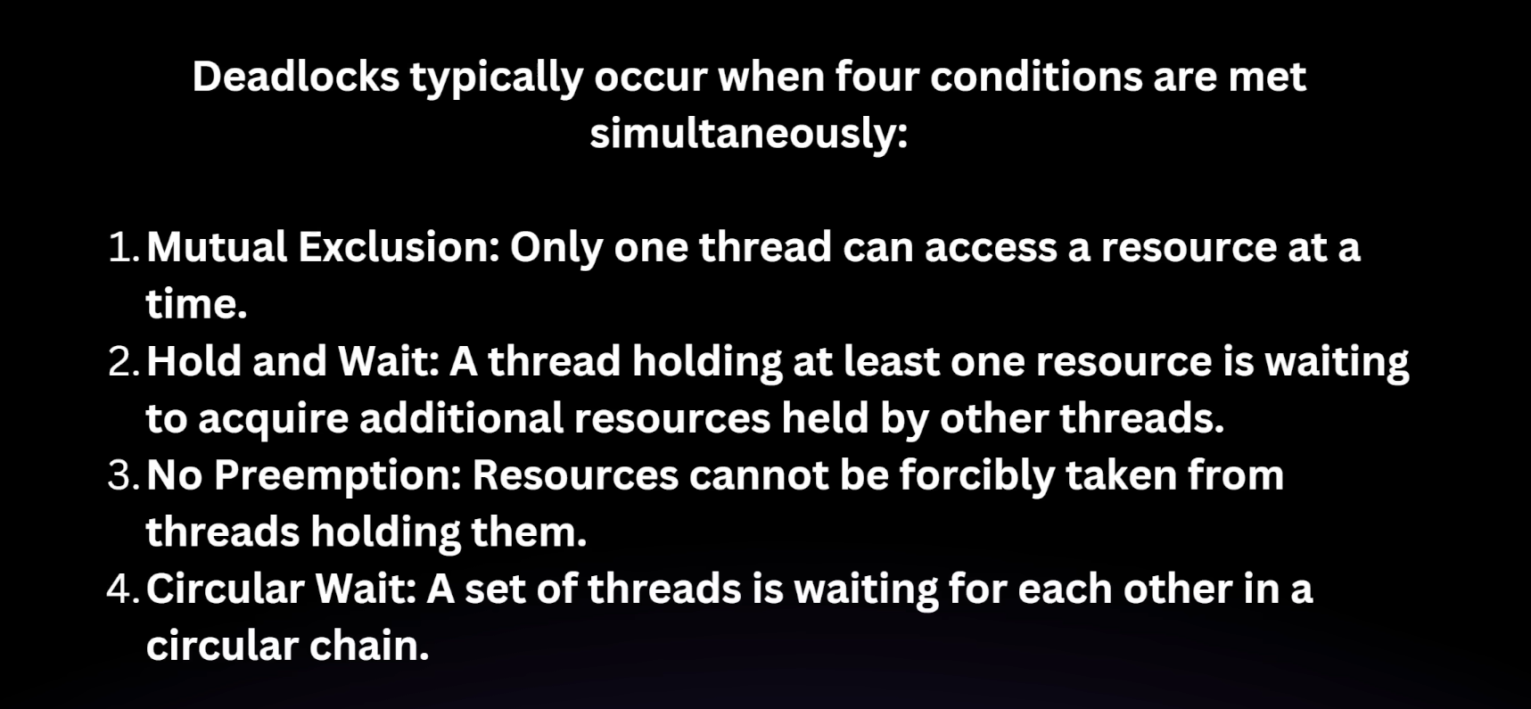

class Pen {
public synchronized void writeWithPenAndPaper(Paper paper) {
System.out.println(Thread.currentThread().getName() + " is using pen " + this + " and trying to use paper " + paper);
paper.finishWriting();
}
public synchronized void finishWriting() {
System.out.println(Thread.currentThread().getName() + " finished using pen " + this);
}
}
class Paper {
public synchronized void writeWithPaperAndPen(Pen pen) {
System.out.println(Thread.currentThread().getName() + " is using paper " + this + " and trying to use pen " + pen);
pen.finishWriting();
}
public synchronized void finishWriting() {
System.out.println(Thread.currentThread().getName() + " finished using paper " + this);
}
}
class Task1 implements Runnable {
private Pen pen;
private Paper paper;
public Task1(Pen pen, Paper paper) {
this.pen = pen;
this.paper = paper;
}
@Override
public void run() {
pen.writeWithPenAndPaper(paper); // thread1 locks pen and tries to lock paper
}
}
class Task2 implements Runnable {
private Pen pen;
private Paper paper;
public Task2(Pen pen, Paper paper) {
this.pen = pen;
this.paper = paper;
}
@Override
public void run() {
synchronized (pen){
paper.writeWithPaperAndPen(pen); // thread2 locks paper and tries to lock pen
}
}
}
public class DeadlockExample {
public static void main(String[] args) {
Pen pen = new Pen();
Paper paper = new Paper();
Thread thread1 = new Thread(new Task1(pen, paper), "Thread-1");
Thread thread2 = new Thread(new Task2(pen, paper), "Thread-2");
thread1.start();
thread2.start();
}
}

Thread communication

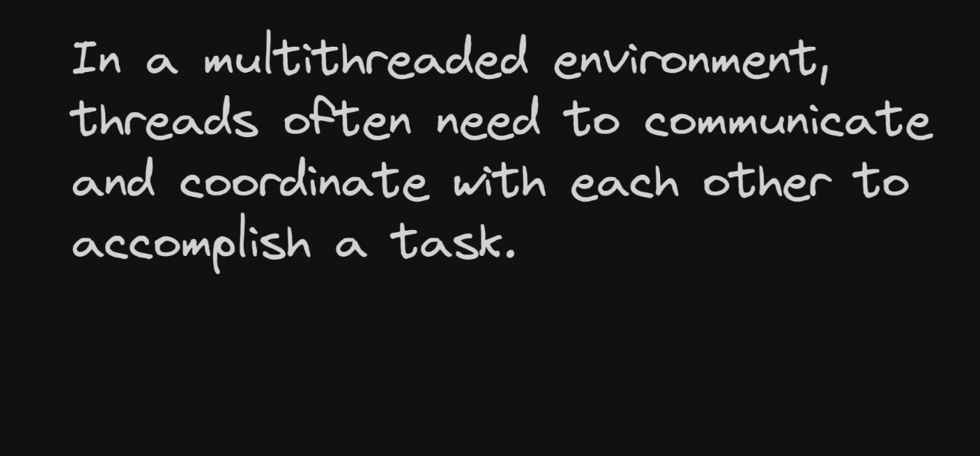



class SharedResource {
private int data;
private boolean hasData;
public synchronized void produce(int value) {
while (hasData) {
try {
wait();
} catch (InterruptedException e) {
Thread.currentThread().interrupt();
}
}
data = value;
hasData = true;
System.out.println("Produced: " + value);
notify();
}
public synchronized int consume() {
while (!hasData){
try{
wait();
}catch (InterruptedException e){
Thread.currentThread().interrupt();
}
}
hasData = false;
System.out.println("Consumed: " + data);
notify();
return data;
}
}
class Producer implements Runnable {
private SharedResource resource;
public Producer(SharedResource resource) {
this.resource = resource;
}
@Override
public void run() {
for (int i = 0; i < 10; i++) {
resource.produce(i);
}
}
}
class Consumer implements Runnable {
private SharedResource resource;
public Consumer(SharedResource resource) {
this.resource = resource;
}
@Override
public void run() {
for (int i = 0; i < 10; i++) {
int value = resource.consume();
}
}
}
public class ThreadCommunication {
public static void main(String[] args) {
SharedResource resource = new SharedResource();
Thread producerThread = new Thread(new Producer(resource));
Thread consumerThread = new Thread(new Consumer(resource));
producerThread.start();
consumerThread.start();
}
}

What is Java Executor Framework?
Last Updated : 19 Aug, 2025

With modern multi-core processors and demand for high-performance apps, multithreading APIs are widely used. Java provides the Executor Framework (java.util.concurrent.Executor, introduced in JDK 5) to run Runnable tasks without creating new threads every time, by reusing existing ones.
The Executors class offers factory methods to create thread pools.
- Threads stay alive and are reused.
- Extra tasks are placed in a queue and free threads pick them up later.
- By default, these queues are unbounded in JDK executors.

Types of Executors in Java
Below are the commonly used executor types:
- SingleThreadExecutor
- FixedThreadPool(n)
- CachedThreadPool
- ScheduledExecutor
Let us discuss these popular Java executors in some detail and what exactly they do to get a better idea before implementing the same.

1. SingleThreadExecutor
A thread pool of a single thread can be obtained by calling the static newSingleThreadExecutor() method of the Executors class. It is used to execute tasks sequentially.
Syntax:
ExecutorService executor = Executors.newSingleThreadExecutor();

2. FixedThreadPool
As the name indicates, it is a thread pool of a fixed number of threads. The tasks submitted to the executor are executed by the n threads and if there are more task, they are stored on a LinkedBlockingQueue. It uses Blocking Queue.
Syntax:
ExecutorService fixedPool = Executors.newFixedThreadPool(2);

3. CachedThreadPool
Creates a thread pool that creates new threads as needed, but will reuse previously constructed threads when they are available. Calls to execute will reuse previously constructed threads if available. If no existing thread is available, a new thread will be created and added to the pool. It uses a SynchronousQueue queue.
Syntax:
ExecutorService executorService = Executors.newCachedThreadPool();

4. ScheduledExecutor
Scheduled executors are based on the interface ScheduledExecutorService which extends the ExecutorService interface. This executor is used when we have a task that needs to be run at regular intervals or if we wish to delay a certain task.
Syntax:
ScheduledExecutorService scheduledExecService = Executors.newScheduledThreadPool(1);
The tasks can be scheduled using either of the two methods:
- scheduleAtFixedRate: This schedules tasks to start at fixed intervals, but if a task takes longer than the interval, the next execution will be delayed. It does not interrupt the running task, but, upcoming executions are queued and wait for the current one to finish
- scheduleWithFixedDelay: This will start the delay countdown only after the current task completes.
Syntax:
scheduledExecService.scheduleAtFixedRate
(Runnable command, long initialDelay, long period, TimeUnit unit)

Future Object in Executor Framework
The result of the task submitted for execution to an executor can be accessed using the java.util.concurrent. The future object returned by the executor. Future can be thought of as a promise made to the caller by the executor. The future interface is mainly used to get the results of Callable results. whenever the task execution is completed, it is set in this future object by the executor.
Syntax:
Future<String> result = executorService.submit(callableTask);

Java Program to Create and Execute a Simple Executor
Implementation: Creating and Executing a Simple Executor in which we will create a task and execute it in a fixed pool
- The Task class implements Callable and is parameterized to String type. It is also declared to throw Exception.
- Now in order to execute task in class “Task” we have to instantiate the Task class and are passing it to the executor for execution.
- Print and display the result that is returned by the Future object
import java.util.concurrent.*;

class Task implements Callable<String> {

private String message;

public Task(String message)
{
this.message = message;
}

public String call() throws Exception
{
return "Hi " + message + "!";
}
}

public class Geeks {

public static void main(String[] args)
{

Task task = new Task("GeeksForGeeks");

// Creating object of ExecutorService class and Future object Class
ExecutorService executorService = Executors.newFixedThreadPool(4);
Future<String> result = executorService.submit(task);

// Try block to check for exceptions
try {
System.out.println(result.get());
}

// Catch block to handle the exception
catch (InterruptedException | ExecutionException e) {

System.out.println("Error occurred while executing the submitted task");
e.printStackTrace();
}

// Cleaning resource and shutting down JVM by saving JVM state using shutdown() method
executorService.shutdown();
}
}

Executors framework
The Executors framework was introduced in Java 5 as part of the java.util.concurrent package to simplify the development of concurrent applications by abstracting away many of the complexities involved in creating and managing threads.
It will help in
- Avoiding Manual Thread management
- Resource management
- Scalability
- Thread reuse
- Error handling

import java.util.concurrent.ExecutorService;
import java.util.concurrent.Executors;
import java.util.concurrent.TimeUnit;
public class ExecutorFrameWork {
public static void main(String[] args) {
long startTime = System.currentTimeMillis();
ExecutorService executor = Executors.newFixedThreadPool(3);
for (int i = 1; i < 10; i++) {
int finalI = i;
executor.submit(() -> {
long result = factorial(finalI);
System.out.println(result);
});
}
executor.shutdown();
// executor.shutdown();
try {
executor.awaitTermination(1, TimeUnit.SECONDS);
} catch (InterruptedException e) {
throw new RuntimeException(e);
}
System.out.println("Total time " + (System.currentTimeMillis() - startTime));
}
private static long factorial(int n) {
try {
Thread.sleep(1000);
} catch (InterruptedException e) {
throw new RuntimeException(e);
}
long result = 1;
for (int i = 1; i <= n; i++) {
result *= i;
}
return result;
}
}

The ExecutorService interface extends Executor by adding methods that help manage and control the execution of threads. It is defined in java.util.concurrent package. It defines methods that execute the threads that return results, a set of threads that determine the shutdown status. The ExecutorService interface is implemented in a utility class called Executors. It defines methods that provide an implementation of the ExecutorService interface and many other interfaces, with some default settings.
The class hierarchy is as follows:
--> java.util.concurrent Package
--> Interface ExecutorService Class

Methods in Executor Interface
Method | Action Performed
awaitTermination() | Waits for all the tasks to complete their execution after a shutdown request is found. It waits for the time specified by the timelimit argument
invokeAll() | Executes all the tasks contained in the collection. The list of Future objects is returned which contains the status and return values of the various tasks
invokeAny() | Executes all the tasks contained in the collection. On completion of any single task it returns its result and all the other tasks are canceled.
isShutdown() | Tells whether the invoking executor is shut down or not. Returns true if shutdown otherwise returns false
isTerminated() | Checks if all the tasks have been completed post-shutdown. Return true if completed, otherwise returns false.
shutdown() | Causes all the currently executing tasks to terminate after completion in the order in which they were started and rejects any new incoming tasks.
shutdownNow() | Forcefully terminates all the tasks, regardless of their current state i.e running, waiting, or ready. The lists of tasks were in a ready state in return.
submit() | Adds a task that returns a result to the list of executing tasks for execution. It returns a Future object which returns the result of the task after completion

CompletableFuture in Java
Last Updated : 23 Jul, 2025

CompletableFuture provides a powerful and flexible way to write asynchronous, non-blocking code. It was introduced in Java 8 and has become popular due to its ease of use and ability to handle complex asynchronous workflows.

What is CompletableFuture?
CompletableFuture is a class in java.util.concurrent package that implements the Future and CompletionStage Interface. It represents a future result of an asynchronous computation. It can be thought of as a container that holds the result of an asynchronous operation that is being executed in a different thread. It provides a number of methods to perform various operations on the result of the async computation.

Creating a CompletableFuture
To create an instance of CompletableFuture, we can use the static method supplyAsync provided by CompletableFuture class which takes Supplier as an argument. Supplier is a Functional Interface that takes no value and returns a result.

import java.util.concurrent.*;

class GFG {

public static void main(String[] args) throws Exception

{

CompletableFuture<String> greetingFuture

= CompletableFuture.supplyAsync(() -> {

// some async computation

return "Hello from CompletableFuture";

});

System.out.println(greetingFuture.get());

}

}
This creates a CompletableFuture that will execute the lambda function passed to supplyAsync in a separate thread. And after the execution, the result lambda function is returned by CompletableFuture Object

Composing CompletableFuture
One of the powerful features of CompletableFuture is its ability to compose multiple asynchronous operations. We can use methods like thenApply, thenCombine, thenCompose to perform operations on the result of one CompletableFuture and create a new CompletableFuture as a result.
Example:

/*package whatever //do not write package name here */

import java.util.concurrent.*;

class GFG {

public static void main(String[] args) throws Exception

{

CompletableFuture<String> helloFuture

= CompletableFuture.supplyAsync(() -> "Hello");

CompletableFuture<String> greetingFuture

= CompletableFuture.supplyAsync(() -> "World");

CompletableFuture<String> combinedFuture

= helloFuture.thenCombine(

greetingFuture, (m1, m2) -> m1 + " " + m2);

System.out.println(combinedFuture.get());

}

}
Output:
Hello World
This creates two instances of CompletableFuture that return "hello" and "world". And using thenCombine, the result of both the CompletableFutures are concatenated and returned as a final result.

Handling Multiple CompletableFutures
Sometimes we need to run multiple independent CompletableFuture tasks in parallel and wait for all of them to complete, so in this case we can use methods like allOf and anyOf.
Example:

import java.util.concurrent.*;

class GFG {

public static void main(String[] args) throws Exception {

CompletableFuture<Integer> f1 = CompletableFuture.supplyAsync(() -> 10);

CompletableFuture<Integer> f2 = CompletableFuture.supplyAsync(() -> 20);

// Running multiple tasks in parallel

CompletableFuture<Void> allOf = CompletableFuture.allOf(f1, f2);

// Waits for both futures to complete

allOf.join();

System.out.println("Future1 Result: " + f1.get());

System.out.println("Future2 Result: " + f2.get());

}

}
Output
Future1 Result: 10
Future2 Result: 20
Note: The allOf() method is used to combine the results of multiple CompletableFuture instances.

Handling Exception in CompletableFuture
CompletableFuture provides methods like exceptionally and handle to handle exceptions and errors that might happen during asynchronous computation and provide a fallback value or perform some alternative operation.
Example:

import java.util.concurrent.*;

class GFG {

public static void main(String[] args) throws Exception

{

CompletableFuture<Integer> resultFuture

// java.lang.ArithmeticException: / by zero

= CompletableFuture.supplyAsync(() -> 10 / 0)

.exceptionally(ex -> 0);

// 0 - returned by exceptionally block

System.out.println(resultFuture.get());

}

}

In Java, a Future represents the result of an asynchronous computation. It's part of the Java concurrency framework introduced in Java 5 with the java.util.concurrent package.

✅ What is Future?
A Future<T> is an object that acts as a placeholder for a result that will eventually be available.
You typically get a Future when you submit a task to an ExecutorService. You can then:
- Check if the task is done
- Block until the task is done and get the result
- Cancel the task

🔧 Basic Example
ExecutorService executor = Executors.newSingleThreadExecutor();
Callable<String> task = () -> {
Thread.sleep(2000);
return "Result after delay";
};

Future<String> future = executor.submit(task);

// You can do other work here...

String result = future.get(); // This will block until the task completes
System.out.println(result);
executor.shutdown();

🧠 Key Methods of Future
Method | Description
get() | Waits if necessary for the computation to complete and then retrieves the result.
get(long timeout, TimeUnit unit) | Waits for a maximum time and throws TimeoutException if the task doesn't complete.
isDone() | Returns true if the computation is complete.
isCancelled() | Returns true if the task was cancelled.
cancel(boolean mayInterruptIfRunning) | Attempts to cancel the execution.

⚠️ Limitations of Future
- Blocking: get() blocks the thread until the result is available.
- No callback mechanism: Can't be notified when the result is ready.
- Difficult chaining: Composing multiple Futures (like running task B after A) is hard.
- No support for reactive-style programming.

🚀 What's Better Than Future?
To overcome its limitations, Java 8 introduced CompletableFuture, which supports:
- Non-blocking async calls
- Chaining and combining tasks
- Functional programming style
- Great question! Here’s a clear comparison between Future and CompletableFuture in Java:

1. Basic Concept
Feature | Future | CompletableFuture
Introduced in | Java 5 (java.util.concurrent) | Java 8 (java.util.concurrent)
Purpose | Represents a placeholder for an async result (blocking) | Represents a future result with support for async non-blocking and event-driven programming

2. How you use them
Aspect | Future | CompletableFuture
Getting result | get() blocks until the result is available | Non-blocking thenApply, thenAccept, etc. and blocking get() also available
Asynchronous chaining | Not supported natively | Supported with methods like thenApply(), thenCompose(), thenCombine(), etc.
Completion callbacks | No native support (you have to block and poll) | Supports callbacks on completion (thenRun(), thenAccept(), etc.)
Exception handling | Exception wrapped in ExecutionException on get() | Rich API for handling exceptions with exceptionally(), handle(), etc.
Manual completion | No way to manually complete a Future | Can be completed manually with complete() or completeExceptionally()
Composition | Difficult, requires complex code | Built-in support for composing futures

3. Example usage
- Future example (blocking):
- ExecutorService executor = Executors.newSingleThreadExecutor();
- Future<String> future = executor.submit(() -> {
- Thread.sleep(1000);
- return "Hello";
- });

- String result = future.get(); // blocks here until done
- System.out.println(result);
- executor.shutdown();

- CompletableFuture example (non-blocking):
- CompletableFuture.supplyAsync(() -> {
- try { Thread.sleep(1000); } catch (InterruptedException e) {}
- return "Hello";
- }).thenAccept(result -> System.out.println("Result: " + result));

- System.out.println("This prints immediately, before result");

4. Summary
Topic | Future | CompletableFuture
Blocking | Yes, get() blocks the thread | Mostly non-blocking, can block if you want
Async callbacks | No | Yes
Composability | Poor | Excellent
Manual control | No | Yes (can manually complete)
Use case | Simple async tasks | Complex async workflows, chaining, combining futures

Future
import java.util.concurrent.ExecutionException;
import java.util.concurrent.ExecutorService;
import java.util.concurrent.Executors;
import java.util.concurrent.Future;
public class Main {
public static void main(String[] args) throws ExecutionException, InterruptedException {
ExecutorService executorService = Executors.newSingleThreadExecutor();
Future<?> future = executorService.submit(() -> System.out.println("Hello")); // runnable parameter
System.out.println(future.get()); // blocking call ( null )
if(future.isDone()){
System.out.println("Task is done !");
}
executorService.shutdown();
}
}
Hello
null
Task is done !
import java.util.concurrent.ExecutionException;
import java.util.concurrent.ExecutorService;
import java.util.concurrent.Executors;
import java.util.concurrent.Future;
public class Main {
public static void main(String[] args) throws ExecutionException, InterruptedException {
ExecutorService executorService = Executors.newSingleThreadExecutor();
Future<String> future = executorService.submit(() -> "Hello"); // callable parameter
System.out.println(future.get()); // blocking call
if(future.isDone()){
System.out.println("Task is done !");
}
executorService.shutdown();
}
}
Hello
Task is done !

ExecutorService vs CompletableFuture
Aspect | ExecutorService | CompletableFuture
What it is | A thread pool manager — handles execution of async tasks on threads | A future with rich API to represent, compose, and chain async computations
Primary role | Manages threads and executes Runnable or Callable tasks | Represents the result of an async computation, with additional methods to build async pipelines
How you submit tasks | executor.submit(Runnable/Callable) | Use static methods like CompletableFuture.supplyAsync() (which uses a default ForkJoinPool or a custom Executor)
Thread management | Explicit thread pool management | Uses internal default thread pool or can be given an Executor to run tasks
Async chaining | Not supported directly — you have to coordinate manually | Supports fluent API for chaining, combining, and handling exceptions
Use cases | Running and managing background tasks (especially blocking or long-running) | Building complex async workflows, event-driven programming, non-blocking pipelines
Manual completion | No | Yes, you can manually complete a CompletableFuture
Blocking behavior | Caller typically blocks on Future.get() | Can be fully non-blocking if you use callbacks and chaining
Example | executor.submit(() -> doWork()) | CompletableFuture.supplyAsync(() -> doWork())

How they work together
- CompletableFuture.supplyAsync() by default uses the common ForkJoinPool (a type of Executor).
- You can pass a custom Executor to supplyAsync() or other async methods to control the thread pool used.
Example:
ExecutorService executor = Executors.newFixedThreadPool(5);

CompletableFuture<String> future = CompletableFuture.supplyAsync(() -> {
// Some CPU or IO-bound task
return "Hello from CompletableFuture!";
}, executor);

future.thenAccept(System.out::println);
executor.shutdown();

Summary
ExecutorService | CompletableFuture
Thread pool to execute async tasks | Async computation abstraction + API
Focus on task execution and management | Focus on handling async results & chaining
Requires blocking on Futures for results | Supports non-blocking, callback-style programming
No direct support for task composition | Rich support for composing and combining async tasks

Atomic classes
public class VolatileCounter {
private AtomicInteger counter = new AtomicInteger(0);
public void increment() {
counter.incrementAndGet();
}
public int getCounter() {
return counter.get();
}
public static void main(String[] args) throws InterruptedException {
VolatileCounter vc = new VolatileCounter();
Thread t1 = new Thread(() -> {
for (int i = 0; i < 1000; i++) {
vc.increment();
}
});
Thread t2 = new Thread(() -> {
for (int i = 0; i < 1000; i++) {
vc.increment();
}
});
t1.start();
t2.start();
t1.join();
t2.join();
System.out.println(vc.getCounter());
}
}

Volatile keyword
class SharedObj {
private volatile boolean flag = false;
public void setFlagTrue() {
System.out.println("Writer thread made the flag true !");
flag = true;
}
public void printIfFlagTrue() {
while (!flag) {
// do nothing
}
System.out.println("Flag is true !");
}
}
public class VolatileExample {
public static void main(String[] args) {
SharedObj sharedObj = new SharedObj();
Thread writerThread = new Thread(() -> {
try {
Thread.sleep(1000);
} catch (InterruptedException e) {
Thread.currentThread().interrupt();
}
sharedObj.setFlagTrue();
});
Thread readerThread = new Thread(() -> sharedObj.printIfFlagTrue());
writerThread.start();
readerThread.start();
}
}

CountDownLatch
import java.util.concurrent.Callable;
import java.util.concurrent.CountDownLatch;
import java.util.concurrent.ExecutorService;
import java.util.concurrent.Executors;
public class Test {
public static void main(String[] args) throws InterruptedException {
int n = 3;
ExecutorService executorService = Executors.newFixedThreadPool(n);
CountDownLatch latch = new CountDownLatch(n);
executorService.submit(new DependentService(latch));
executorService.submit(new DependentService(latch));
executorService.submit(new DependentService(latch));
latch.await();
System.out.println("Main");
executorService.shutdown();
}
}
class DependentService implements Callable<String> {
private final CountDownLatch latch;
public DependentService(CountDownLatch latch) {
this.latch = latch;
}
@Override
public String call() throws Exception {
try {
System.out.println(Thread.currentThread().getName() + " service started.");
Thread.sleep(2000);
} finally {
latch.countDown();
}
return "ok";
}
}
pool-1-thread-3 service started.
pool-1-thread-2 service started.
pool-1-thread-1 service started.
Main

Cyclic Barrier
import java.util.concurrent.BrokenBarrierException;
import java.util.concurrent.CyclicBarrier;
public class Main {
public static void main(String[] args) {
int numberOfSubsystems = 4;
CyclicBarrier barrier = new CyclicBarrier(numberOfSubsystems, new Runnable() {
@Override
public void run() {
System.out.println("All subsystems are up and running. System startup complete.");
}
});
Thread webServerThread = new Thread(new Subsystem("Web Server", 2000, barrier));
Thread databaseThread = new Thread(new Subsystem("Database", 4000, barrier));
Thread cacheThread = new Thread(new Subsystem("Cache", 3000, barrier));
Thread messagingServiceThread = new Thread(new Subsystem("Messaging Service", 3500, barrier));
webServerThread.start();
databaseThread.start();
cacheThread.start();
messagingServiceThread.start();
}
}
class Subsystem implements Runnable {
private String name;
private int initializationTime;
private CyclicBarrier barrier;
public Subsystem(String name, int initializationTime, CyclicBarrier barrier) {
this.name = name;
this.initializationTime = initializationTime;
this.barrier = barrier;
}
@Override
public void run() {
try {
System.out.println(name + " initialization started.");
Thread.sleep(initializationTime); // Simulate time taken to initialize
System.out.println(name + " initialization complete.");
barrier.await();
} catch (InterruptedException | BrokenBarrierException e) {
e.printStackTrace();
}
}
}

